Simulation study on lateral spread and penetration depth of electron beam into the material of nearly same density

Bibek Gautam¹, Hari Kishor Shah¹, Vinaya Kumar Jha¹

¹Department of Physics, St. Xavier’s College, Kathmandu, Nepal.

Corresponding Email: bibek.gautam@sxc.edu.np

Received: 14 April 2021; Accepted: 01May 2021; Published:

Abstract: Our work is a simulation study of the variation of interaction volume, lateral spread and penetration depth of electron beam in the elemental species due to electronic cloud density variation. We picked three pairs of elements with similar densities (varying in the second order in gm/cm³.) The variations were studied across a range (10 KeV to 30 KeV) of beam energy. A nearly linear positive relationship is observed between penetration depth and beam energy. Our results confirm that the electronic could density affects the interaction volume more significantly than the mass density of the target material. The results obtained are presented in figures.

Keywords: electron interaction, interaction volume, lateral spread, penetration depth, simulation

- Introduction

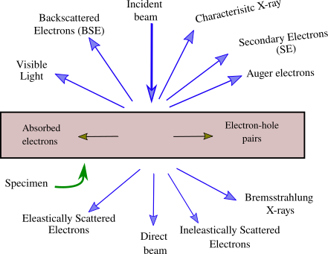
Discovered by J. J. Thompson in 1897, an electron is an elementary particle with a charge of −1.6 × 10⁻¹⁹ C and a mass ₁₈₃₆¹ times that of a proton. In standard the model of particle physics, an electron belongs to the first generation of the lepton particle family with ¹₂ spin. When a beam of electrons (primary electrons) is incident on matter (target), a variety of interaction phenomena occur. The electrons interact with nuclei and the electron clouds present in the target atoms. Most of these are various forms of Coulomb interactions between the beam electrons and the electron cloud and the nucleus of the atom. There arise some quantum mechanical effects when the incident electron carries high enough energy. Understanding these interactions and the signals they generate is crucial to the workings of electron microscopes. A schematic representation of various interactions that takes place is given in the figure below:

Fig. 1: Electron-matter interaction showing different possible outcomes

The interactions can broadly be classified as elastic and inelastic interactions. In elastic interactions, no energy is deposited by the electron beam onto the sample. This occurs primarily due to the deflection of the electron from its path by the positive potential barrier of the electron cloud. These electrons are exploited in TEM and electron diffraction methods. The electrons that suffer elastic collision with the nucleus can scatter back from the sample, giving rise to what are called back scattered electrons (Kanaya & Okayama, 1972). In inelastic interaction, the total kinetic energy of the incident electron is not conserved. Some energy is transmitted to the sample which reduces the subsequent energy of the electron.

The energy deposited in the sample might lead to the production of various signals (such as secondary electrons, phonon excitation [heating], cathodoluminance, continuum radiation, characteristic X-ray production, plasmon production, Auger electron production, etc.) Here, we are mostly concerned about the secondary electron.

Secondary electrons

Electrons emitted from the metal surface when charged particles like electron or ions are incident on it are called Secondary Electrons (SE). Several mechanisms of inelastic interaction lead to SE emission. Electrons located in the valence or conduction band need only a small amount of energy to overcome the work function and be free from the atom. SE electrons thus emitted from the sample surface typically carry energies below 50 eV and are designated as slow SEs (Kim, 1975). These are utilized in scanning electron microscopy (SEM). They help study the morphology and surface topography. Electrons located in the inner shells are strongly bound to the atom and therefore are less readily emitted. This process also leads to the ionization of the atom, but unlike the previous case, it leads subsequently to the generation of characteristic X-rays. Alternatively, some other electron can be released from the same atom, taking a portion or whole of the energy of the characteristic X-rays. These electrons from the inner shells carry rather large energy and are known as fast SEs.

Interaction volume

When the incident electron beam enters the specimen, it can potentially undergo various scattering events. The combined effect of elastic and inelastic interactions is the penetra-tion of the beam into the solid. The region of interaction between the solid and beam is called the interaction volume. Two main factors which limit the type of interaction that is detected in the interaction volume are:

- The electron drops in energy as it penetrates the sample due to interaction with the sample and it is impossible to produce an effect from deeper portions if it requires large energy.

- The degree to which an effect, once produced, can be detected which depends on how strongly it is diminished by absorption and scattering in the sample (Ziman, 2001).

Penetration depth is the distance from the surface to the deepest that an electron from the impinging beam reaches into the specimen.
A theoretical expression for the range of an electron, the straight line distance between where an electron enters and its final resting place, for a given E_{o} is Kanaya and Okayama, 1972:

r(µm) = | 2.76 × 10⁻²A E_{o}^{1.67} | (1)
r(µm) = | _{ρ} _{Z}0.89 | (1)

where,
E_{o} = accelerating voltage (keV)
- = density (g/cm³)

The shape and size of the interaction volume is controlled by energy loss through elastic and inelastic interaction. The depth of penetration of the electron beam and the volume of the sample with which it interacts are function of the angle of incident, the magnitude of its current, the accelerating voltage, and the average atomic number of the sample. The interaction volume depends on various factors.

Factors affecting interaction volume

- Beam energy

The energy of the incident beam (which depends on accelerating potential) determines the volume of interaction. The greater the energy of each individual electron in the beam, the longer it takes before its energy is totally dissipated or emitted. Thus, it suffers a greater number of scatterings and also penetrates deeper, in general, into the sample. Accelerating voltage plays the largest role in determining the depth of electron interaction.

- Density

Density plays the second largest role in determining the depth of electron interaction. If the atom is dense, it offers greater deceleration on collision. This explains the inverse relation density has with the range of an electron into the sample.

- Atomic number

The samples with large atomic numbers have more electrons in the cloud shielding the atom. An incoming electron is thus more likely to be scattered with greater angles compared to that in the samples with lower atomic weights.

- Surface tilt

If the surface is tilted at an angle with respect to the beam, the interaction volume is smaller and asymmetric. The interaction volume is symmetric and largest in a sample perpendicular to the incident beam.

We have a few more variables that we can control in our simulation besides the ones discussed above. Beam radius and the number of electrons used can also determine the way interaction volume looks in the simulation.

Studying the interaction volume, penetration depth, and intensity distribution of various signals obtained as a result of the interaction of electron with matter has been of intellectual and practical importance to physicists since the early twentieth century. Full understanding of the various interaction phenomena and the signals they generate can be
useful to devise and improve various instrumentation techniques of studying microscopic physical characteristics of metals and substances (Kanaya & Okayama, 1972). Electron solid interaction has been of particular interest to physicists because of its applicability. Study of characteristic X-ray generation is useful in the production of X-ray pulses to the order of femtosecond (Schoenlein et al., 2000) which is useful in laser induced synthesis of nanoparticles (Eliezer et al., 2004). Various signals generated in the interaction have been exploited in devices such as SEM, TEM, STEM, etc. Monte Carlo methods have been extensively used in physics and mathematics when using other methods is often impossible (Kroese et al., 2014). Computer simulation study of electron interaction with solids have been conducted since the 70s.

2. Research Methodology

2.1 Monte Carlo simulation

We’ve used computer simulation as a methodology in this study. Monte Carlo Simulation is a technique that relies on random sampling for modeling the uncertainty of a certain system. The random variables are modeled on the basis of some probability distribution such as normal, log normal, etc. Multiple iterations or simulations are run to arrive at the outcome. This is done with the help of numerical computation.

In the electron trajectory simulation, the electron trajectory is followed in a step-wise method from its entry point in the target until it loses all of its energy and is absorbed or until it is back-scattered. With the probability of electrons undergoing scattering, the scattering angle, the distance between scattering events and the rate of energy loss is determined at each point from an appropriate physical model. The position of an electron within the sample and its kinetic energy is updated with time at a small enough time-step that is necessary to achieve the required precision. As electron-solid interaction is a stochastic process at the fundamental level, random numbers and weighting factors are used to repeat the statistical distribution of scattering events. The accuracy of the simulation, therefore, utterly depends on the models and assumptions used. Monte Carlo methods themselves, however, have been verified by hundreds of comparisons with experimental values.

For our purpose, we have used CASINO (version 2.42) which stands for monte CArlo SImulation of electroN trajectory in sOlids (Drouin et al., 2007). This program is par-ticularly designed for low energy beam interaction in bulk or thin samples and can be exploited to produce back-scattered electrons and characteristic X-rays as a point analysis or as a line scan for accelerating voltages between 0.1 to 30 KeV.

2.2 Variables under study

Among the various factors that determine interaction volume, we are interested in only few in this study. We do not study the variation due to density in this work. But we want to examine the role atomic number plays in determining the interaction volume, the penetration depth and the lateral spread of the beam. For this, we looked for pure elements with nearly the same densities. We have tolerated the variation in the second order of densities(gm/cm³).
2.3 Selection of sample

In this study, we have picked three pairs of pure elements sample having similar density and tried to figure out how the interaction volume and lateral spread changes with the atomic number.

The three pairs with the atomic number and densities are listed in the table below.

Sample | Atomic Weight | Density
Beryllium | 4 | 1.85
Caesium | 55 | 1.87
Iron | 26 | 7.87
Gadolinium | 64 | 7.89
Cerium | 58 | 6.78
Praseodymium | 59 | 6.77

Table 1: Sample pairs chosen for study

Beryllium (Be) and Caesium (Cs) have similar densities as shown in the table above. The atomic number of Be (4) is much lower than that of Cs (55). Therefore, we expect that the interaction of an electron beam with Be sample would be significantly different that that with the Cs sample. Similarly, Iron (Fe) with an atomic number of 26 has similar density to the Gadolinium (Gd) sample with an atomic number 64. Again, we expect a significant difference in the interaction volume and lateral spread between these specimens. Lastly, Cerium (Ce) with an atomic number 58 and Praseodymium (Pr) with an atomic number of 59 have similar densities as shown in the table 1. Since the atomic numbers of these specimens are very similar, we expect that there will not be distinct variation in the interaction volume of the beam.

3. Result

We ran the simulation of all these specimens with a beam of radius 10 nm incident perpendicularly at the surface. The total number of electrons were chosen to be 5000. The energy of electron was varied from 10 KeV to 30 KeV with a step size of 5 KeV.

3.1 Variation due to beam energy

Beam energy was found to a have positive correlation with the interaction volume. Inter-action volume was found to steadily rise with the increasing beam energy. The variation with the beam energy for Iron (Fe) sample, chose for demonstration for no particular reason, is shown in the figure below.
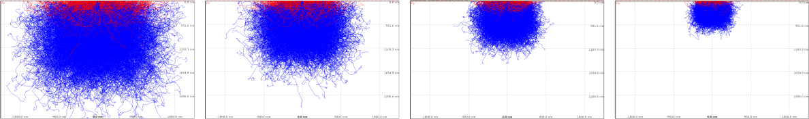

(a) 30 KeV (b) 25 KeV (c) 20 KeV (d) 15 KeV

Fig. 2: Change in interaction volume with beam energy (Fe-26)

The penetration depth and the lateral spread for Iron sample is shown in the table below:

Beam Energy (KeV) | Lateral Spread (nm) | Penetration Depth (nm)
30 | 3518.1 | 2818.1
25 | 2585.4 | 1865.4
20 | 1832.7 | 1161.8
15 | 1161.8 | 720.0
10 | 572.7 | 409.1

Table 2: Lateral spread and penetration depth for Fe-26

A plot of lateral spread vs. energy and penetration depth vs. energy is shown in the figure below.
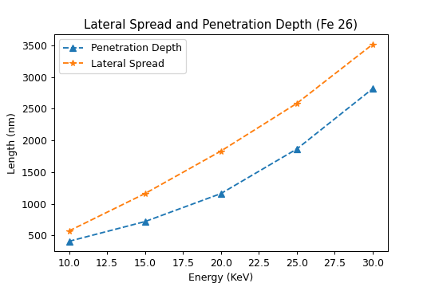

Fig. 3: Lateral spread and penetration depth vs. beam energy (Fe 26)

A similar trend in the interaction volume is also seen in the Caesium (Cs-55) and Praseodymium (Pr-59) Samples. These are also shown in the figure below.
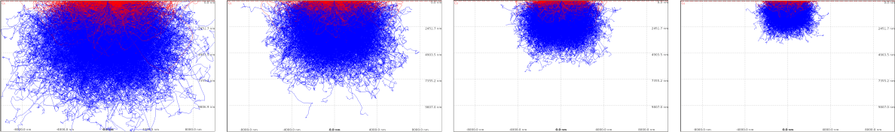

(a) 30 KeV (b) 25 KeV (c) 20 KeV (d) 15 KeV

Fig. 4: Change in interaction volume with beam energy (Cs-55)
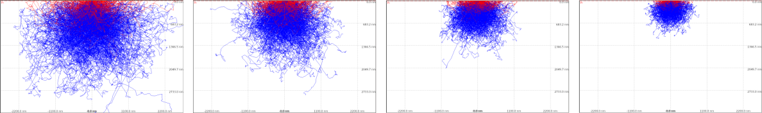

(a) 30 KeV (b) 25 KeV (c) 20 KeV (d) 15 KeV

Fig. 5: Change in interaction volume with beam energy (Pr-59)

3.2 Variation due to atomic number

We had chosen two pairs of samples with similar densities but dissimilar atomic numbers and a pair of samples with similar densities and atomic numbers1. In the first two pairs, namely Iron-Gadolimium and Beryllium-Caesium pairs, we saw a distinct variation in the interaction of electron beams. In the samples with lower densities, i.e., Beryllium and Iron, the beam was found to penetrate into the sample without much deviation. Therefore, the lateral spread in these samples were lower in comparison with the corresponding pairs.

On the other hand, the third sample showed virtually no variation in the interaction volumes between the pairs. The interaction volume and the lateral spread remained similar for both the samples across the variation in beam energy. The following table contains the lateral spread and penetration depth data for all the specimens chosen for study at 30 KeV energy beam. A visualization is shown in the scatter plot 9 in the following pages.

Sample | Lateral Spread (nm) | Penetration Depth (nm)
Fe | 12634.8 | 11635.2
Gd | 1745.2 | 10908.0
Be | 14544.0 | 12071.5
Cs | 17816.4 | 12362.4
Ce | 5200.1 | 3300.8
Pr | 5100.6 | 3340.0

Table 3: Lateral spread and penetration depth at 30 KeV
A comparison of the interaction volumes of the pair for various energy levels is presented in Figure 6, 7 and 8.

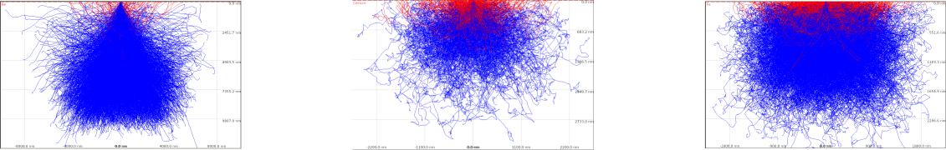

(a) Beryllium (Be 4) (b) Cerium (Ce 58) (c) Iron (Fe 26)
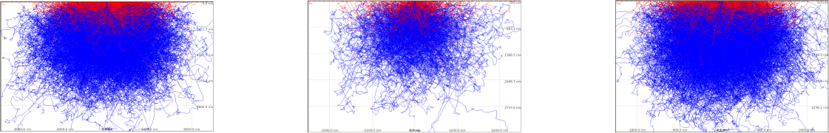

(d) Caesium (Cs 55) (e) Praseodymium (Pr 59) (f) Gadolimium (Gd 64)

Figure 6: Interaction Volume at 30 KeV
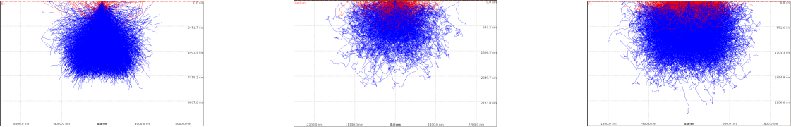

(a) Beryllium (Be 4) (b) Cerium (Ce 58) (c) Iron (Fe 26)
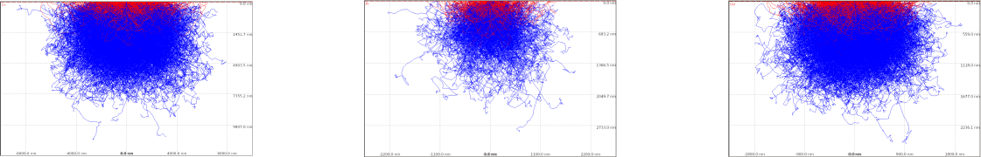

(d) Caesium (Cs 55) (e) Praseodymium (Pr 59) (f) Gadolimium (Gd 64)

Figure 7: Interaction Volume at 25 KeV
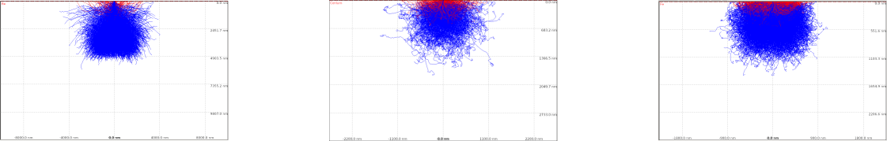

(a) Beryllium (Be 4) (b) Cerium (Ce 58) (c) Iron (Fe 26)
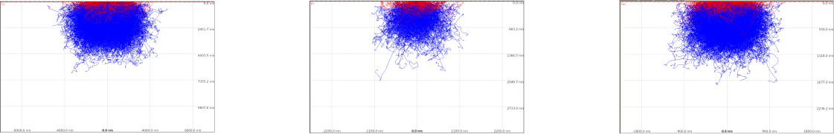

(d) Caesium (Cs 55) (e) Praseodymium (Pr 59) (f) Gadolimium (Gd 64)

Fig. 8: Interaction volume at 20 KeV

The figure below shows the variation among the sample pairs using the data in Table 3 in a scatter plot.
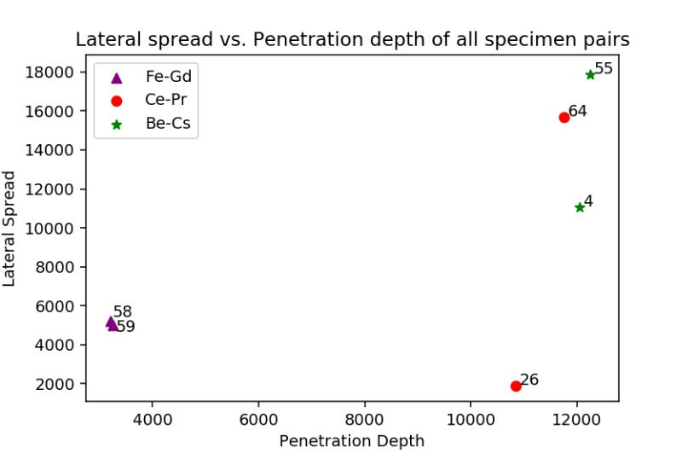

Fig. 9: Lateral spread - penetration depth scatter plot

Specimens with similar densities and dissimilar atomic numbers are distant from each other while specimens with both densities and atomic numbers similar to each other lie very close to each other. This also conveniently demonstrates our result.

4. Discussion

We conclude that the penetration depth, lateral spread and the interaction volume does indeed depend on the energy of the electron beam and the atomic number of the sample. In accordance with our hypothesis, the atomic number does in fact play a role in determining the lateral spread of the beam into the specimen. And also the energy of the electron beam directly affects the lateral spread and penetration depth. The range of electron into the sample is found to depend somewhere between linear to quadratic terms of energy which is in accordance with the theoretical expression due to Kanaya and Okayama (1972).

This work can be extended further in a few meaningful ways. Firstly, one could simulate the interactions with finer steps in beam energy, then plot and fit the observed values of lateral shift and penetration depth. This can then be compared against the theoretical relation.

CASINO also allows one to specify custom density to any material specimen. It would be interesting to see how what the simulation result varies across different densities for some same specimens. One could also be interested in looking at the variation in the back-scattered electron intensity for specimen with varying atomic numbers and thus different nuclear sizes.

5. Acknowledgement:
Authors would like to acknowledge the support of St. Xavier’s College in facilitating this work as a part of Fr. Locke and Fr. Stellar Research Award (LSRA – 2019) project.

6. Conflicts of interest: The authors declare no conflict of interest.
7. References

Drouin, D., Couture, A. R., Joly, D., Tastet, X., Aimez, V., & Gauvin, R. (2007). Casino v2. 42—a fast and easy-to-use modeling tool for scanning electron microscopy and microanalysis users. Scanning: The Journal of Scanning Microscopies, 29(3), 92– 101. DOI: 10.1002/sca.20000

Eliezer, S., Eliaz, N., Grossman, E., Fisher, D., Gouzman, I., Henis, Z., Pecker, S., Horovitz, Y., Fraenkel, M., Maman, S., et al. (2004). Synthesis of nanoparticles with femtosecond laser pulses. Physical Review B, 69(14), 144119.
DOI: 10.1103/PhysRevB.69.144119

Kanaya, K., & Okayama, S. (1972). Penetration and energy-loss theory of electrons in solid targets. Journal of Physics D: Applied Physics, 5(1), 43. DOI:10.1088/0022-3727/5/1/308

Kim, Y.-K. (1975). Energy distribution of secondary electrons i. consistency of experimental data. Radiation research, 61(1), 21–35. DOI:10.2307/3574055

Kroese, D. P., Brereton, T., Taimre, T., & Botev, Z. I. (2014). Why the monte carlo method is so important today. Wiley Interdisciplinary Reviews: Computational Statistics, 6(6), 386–392. DOI:10.1002/wics.1314

Schoenlein, R., Chattopadhyay, S., Chong, H., Glover, T., Heimann, P., Leemans, W., Shank, C., Zholents, A., & Zolotorev, M. (2000). Generation of femtosecond x-ray pulses via laser–electron beam interaction. Applied Physics B, 71(1), 1–10.
DOI:10.1007/PL00021152

Ziman, J. M. (2001). Electrons and phonons: The theory of transport phenomena in solids.

Oxford University Press. DOI:10.1093/acprof:oso/9780198507796.001.0001

